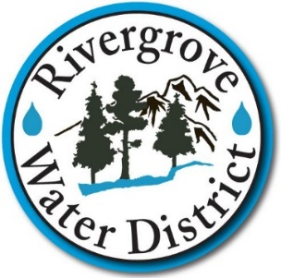
Board of Commissioners Monthly Meeting
Monday, February 28, 2022, 4:30 PM
17661 Pilkington Road, Lake Oswego OR

AGENDA ITEMS

I. Call to Order 4:30 PM

II. Auditor’s Report to the Board Mr. Russell Ries, CPA 4:31 PM
Jarrad, Seibert, Pollard & Co. LLC

III. Public Comment (2 Minute Limit) 4:45 PM

IV. Review and Approval of Minutes 4:50 PM
- January 24, 2022 Regular Meeting

V. Monthly District Report 4:55 PM

- Water Operations/Finance/Admin/HR

VI. Unfinished Business 5:15 PM

- Board Priorities Update

VII. New Business
- Resolution 2022-01: Annual Review Mr. Mark Knudson 5:20 PM
of District Board Policy Handbook SDAO

VIII. Chair Report 5:30 PM

IX. Executive Session (ORS 192.660(2)(i) 5:35 PM

X. Reconvene Regular Session 6:30 PM
(Board to consider action on any items referred from Executive Session)

XI. Adjournment 6:35 PM

Next Regular Meeting: Monday, March 28, 2022 at 4:30 PM

Join Zoom Meeting
https://us06web.zoom.us/j/89274117849?pwd=UElLbFRCazUrYVoxRVZVRzUyOFJndz09&from=addon
Meeting ID: 892 7411 7849 Passcode: 771506 One tap mobile
+12532158782,,89274117849#,,,,*771506# US (Tacoma)
+16699006833,,89274117849#,,,,*771506# US (San Jose)
Dial by your location
+1 253 215 8782 US (Tacoma) +1 669 900 6833 US (San Jose) +1 346 248 7799 US (Houston)
+1 312 626 6799 US (Chicago) +1 929 205 6099 US (New York) +1 301 715 8592 US (Washington DC)
Passcode: 771506 Find your local number: https://us06web.zoom.us/u/kwkEm2PL

